Carrus Tableau Access

Page: https://tableau.carrusdev.com/#/site/External/views/CorporatePartnerPerformanceToolExternal/IntroPartnerSelectionPage?:iid=3
User: asmith@mtpca.org
PW: MPCA2023
For pulling for a specific site:
Choose site from Partner drop down (only sites with enrollments will populate)
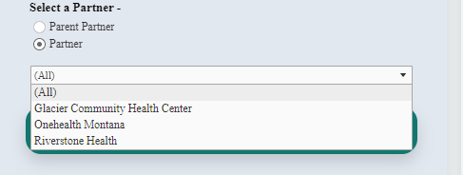
Then follow the steps below

For pulling all learners across the MPCA:
- Step 1: Click on ‘View Corporate Partner Performance Tool’
- Step 2: Scroll to ‘Enrollment Section’
  - Click on Dental Assistant Entry Level then scroll down (If you click anywhere vs scrolling you will have to re-select the program and scroll again)
- Step 3: Click on learner name you want to view
  - You can leave it as all or choose a specific learner
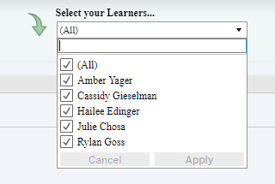
  - Click on green arrow (not the text) in the upper right above the list, this will load the ‘Learner Program Performance Record’

    - Click the ’Go’ button on the right, this will load the ‘Course Section’ below with details

    - Click the ‘Go’ button to the right of any course and it will load the ‘Module Section’ below that. This will allow you to see where they are within the module and quiz/exam scores

To go back you will need to use the arrow in the top left corner. This will take you back to the beginning, unfortunately there isn’t a back option to take you out in stages. You can also click on the name of the Tool at the top and it will take you back as well. Then you will click on ‘Corporate Partner Performance. (You will see other

- Step 4: Pulling a Report
  - On landing page, look for the first download button
  - Click button and it will populate the report
  - Click download button in the dark blue bar above it to download a copy
    - Choose crosstab
      - Choose format
        - Excel is prettier, CSV will allow you to do calculations etc if you want to

