[Name of Health Center] Workforce Development Plan

Workforce needs and resources assessment
Completed:
Last Reviewed:

Documentation of Board approval
Date:

Added to strategic plan
Completed:
Last Reviewed:

Mission, Vision, and Goals identified
Completed:
Last Reviewed:

Activities identified for all six components of the Workforce Development Spectrum
Completed:
Last Reviewed:

Key Performance Indicators
Completed:
Last Reviewed:

Assessment: Workforce Needs and Resources
Need | Cause(s) | Resources we have | Resources we need

[Name of Health Center] Workforce Development Plan

Mission

The mission of [Health Center’s] Workforce Development Plan is

Vision
The mission of [Health Center’s] Workforce Development Plan is

Goals

1.

2.

3.

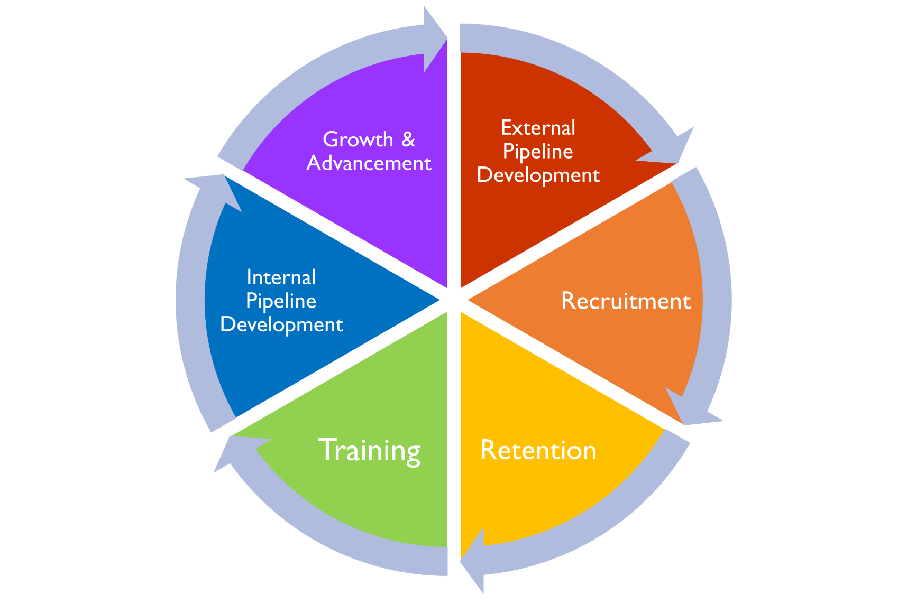

Key Performance Indicators
KPI | Baseline | Goal

